**Steps in part-1**

Step-01: culture media preparation

Step-02: sample preparation

Step-03: non-selective enrichment

Step-04: selective enrichment

Step-05: isolation of bacteria

Step-06: selection of bacteria

**Culture Media preparation**

1. Bismuth bisulphite agar (BSA)
2. Rappaport Vassiliadis soy broth (RSV)
3. MKTTn broth
4. X.L.D Agar

**Xylose Lysine Deoxycholate (XLD) Agar**

1. Dissolve 5.668g XLD Agar powder into 100ml distilled Water.
2. Heat at boiling point for 2 minutes & stir to dissolve the medium completely.
3. Distribute 18ml into sterile petri dishes and cool to solidify.

**Bismuth Sulphite Agar (BSA)**

1. Dissolve 5.232g Bismuth Sulphite Agar powder into 100ml Distilled Water.
2. Heat at boiling point for 2 minutes & stir to dissolve the medium completely.
3. Distribute 18ml into sterile petri dishes and cool to solidify.

**Buffered Peptone Water (BPW)**

1. Dissolve 25.5g Buffered Peptone Water powder into 1000ml Distilled Water.
2. Autoclave at 1210C temperature and 15 lbs pressure for 15 minutes.

**Rappaport Vassiliadis Soya (RVS) Broth**

1. Dissolve 2.71g RVS Broth powder into 100ml Distilled Water.
2. Heat to dissolve the medium completely and distribute 10ml into Glass Test Tubes.
3. Sterile by autoclaving at 115 ℃ and 15 lbs pressure for 15 minutes.

**Muller-Kauffmann Tetrathionate Novobiocin (MKTTn) Broth**

1. Dissolve 89.4g MKTTn Broth powder into 1000ml Distilled Water.
2. Heat the Medium to Just Boiling and cool it at 45- 48℃. Add 1 vial of MKTTn supplement (FD203) and 20ml iodine-iodide Solution.
3. Distribute 10 ml into glass test tubes.

**Sample preparation**

1. Take about 25g sample into a sterile bag and label the bag with sample name.
2. Take the sample in a biosafety cabinet.
3. Measure 225 ml buffered peptone water aseptically and pour it into the bag.
4. Shake the bag to mix the content, vortex the mixture to homogenize the sample for 15 sec.
5. Now incubate the mixture at 37 ℃ for 24h for non-selective enrichment.

**Procedure:**

1. We will use RSV and MKTTn broth for selective enrichment of salmonella.
2. Shake the bag to mix the culture properly and transfer 1 ml buffered peptone water enrichment culture into MKTTn broth and attach the cap loosely.
3. Transfer 0.1 ml buffered peptone water enrichment culture into RSV broth and attach the cap loosely.
4. Now, vortex both test tube for 10 seconds and
5. Incubate the MKTTn broth at 37℃ and RSV broth at 41.5℃ for 24 h for selective enrichment.
6. After incubation, take out RSV and MKTTn broth cultures.
7. Now streaking from RVS Enrichment on BSA Plate for Trial-1 and Trial-2 plates.
8. Streaking from RVS Enrichment on XLD Plate for Trial-I and Trial-2 plates.
9. Streaking from MKTTn enrichment on BSA plate and XLD plate.
10. Now incubate the inoculated XLD & BSA plates at 37℃ for 24.

**Observation:**

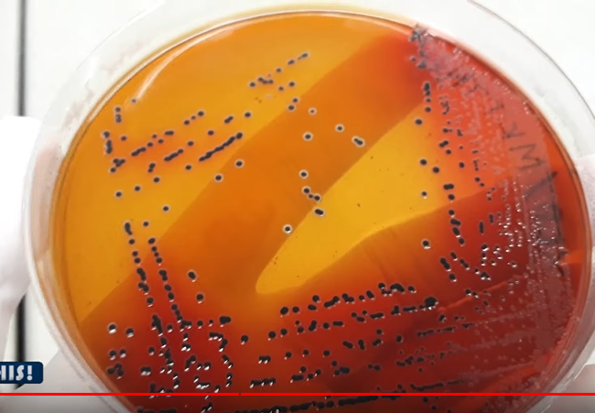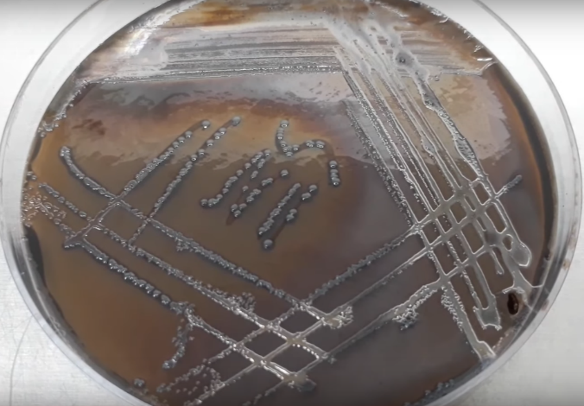

|  |  |
| --- | --- |
| *Black colonies on XLD plate are primarily considered as Salmonella spp.* | *Black to grey colonies turned the BSA media color into black. These black or grey colonies are primarily considered as salmonella spp.* |

**Part 2: Biochemical Identification**

Step-01: media preparation

Step-02: reagent preparation

Step-03: pure culture preparation

Step-04: biochemical tests

Step-05: result observation

Step-06: result interpretation

**Required Medias**

1. Triple Sugar Iron (TSI) Agar
2. MR-VP Medium
3. Simmon Citrate Agar
4. LIM Medium
5. Urea Agar

**Reagents**

1. For Indole Test Kovacs Reagent: Commercially prepared Kovacs Reagent is Available
2. For MR Test Methyl Red Solution: Dissolve 1g Methyl Red Indicator Powder into 100ml Ethanol
3. For VP Test 1-Napthanol Solution: Dissolve 1.2g of 1-Napthanol Powder into 20ml Ethanol.
4. For VP Test Potassium Hydroxide Solution: Dissolve 20g of Potassium Hydroxide Pellets into 50ml Distilled Water.
5. For VP test Creatine Solution: Dissolve 0.5g Creatine Monohydrate into 100ml Distilled Water.

**Procedure**

1. Take 7 stoppered test tube with citrate agar, MR-VP medium, MIU agar, LIM medium, Urea agar and TSI agar.

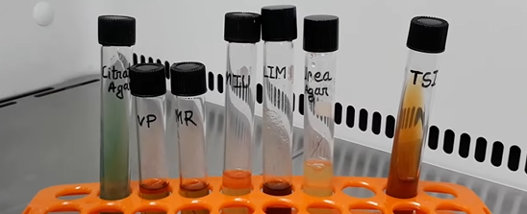

1. Streak Black Colonies on TSA Plate from XLD Culture plate.
2. Streak Black Colonies on TSA Plate from BSA Culture Plate.
3. Now incubate the inoculated TSA plates at 37°C for 24 hours.
4. Inoculate the MR-VP medium with the suspected Salmonella colony for MR test. Attach the cap and rotate the tube to mix the content.
5. Inoculate the MR-VP medium with the suspected Salmonella colony for VP test. Attach the cap and rotate the tube to mix the content.
6. 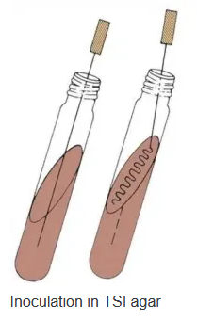Inoculate the slant & butt of TSI with the suspected Salmonella colony. Stub into the butt and then streak on the slant surface of TSI Agar then attach the cap.
7. Inoculate the slant & butt of Simmon citrate Agar with the suspected Salmonella colony. Stub into the butt and then streak on the slant surface.
8. Now stub into the MIU medium without disturbing the surrounding media for motility, indole and urea test.
9. Now stub into the LIM medium to inoculate it for lysin decarboxylation test.
10. Now stub into the Urea Agar medium to inoculate it for urea utilization test.
11. Loose the cap and incubate all of the inoculated tubes at 37°C for 24 hours.

**Observation:**

1. **TSI:** Black color butt is formed due to hydrogen sullite formation and slant turned into red due to dextrose fermentation. The medium is lifted-up from the bottom due to the gas production.

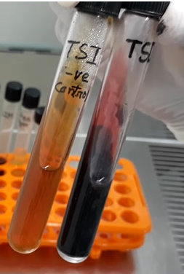

1. **LIM:** The media color is turned into purplish. So. the bacteria showed positive reaction for this test.

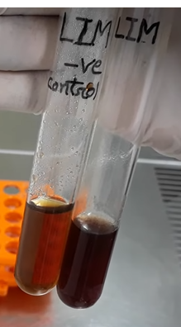

1. **SCA:** The media color is turned into blue from green. So, the bacteria is Citrate positive

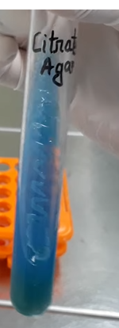

1. **MUI**: Media colour is not turned into pink. So, the bacteria is urea negative. Growth pattern shows the bacterial growth is spread out throughout the media outside of the stub-line. That's why the bacteria is motile. Now, add few drops of Kovacs reagent. No cherry ring is found indicating that the bacteria is indole negative

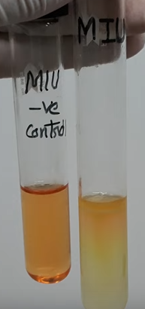

1. **Urea Agar:** No pink color is formed in the Urea Agar. So, the bacteria can't utilize Urea.

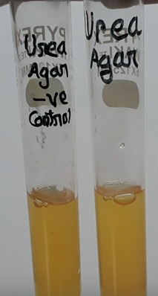

1. **MR:** Add few drops of methyl red solution into the MR tube. Red color development indicates that the bacteria is positive for MR test.

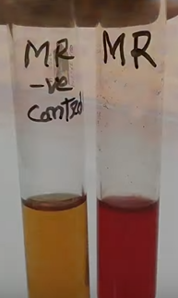

1. **VP:** Add 3 drops of creatine solution. Now, add 2 drops of 1-napthol and finally add 3 drops of potassium hydroxide solution. Close the tube with it's cap and shake slightly to mix the reagents. No pink or red color in 15 min indicates the bacteria is VP negative.

|  |  |  |  |  |  |  |  |  |  |
| --- | --- | --- | --- | --- | --- | --- | --- | --- | --- |
|  | TSI slant | H2S & Gas | Motility test | Indole test | Urea test | Lysine decarboxylase | Citrate Utilization | MR reaction | VP reaction |
| Typical salmonella spp. | Red | +ve | +ve | -ve | -ve | +ve | +ve | +ve | -ve |
| Suspected Bacteria | Red | +ve | +ve | -ve | -ve | +ve | +ve | +ve | -ve |

**Composition of Bismuth Sulphite Agar (BSA)**

|  |  |
| --- | --- |
| **Ingredients** | **Gms/liter** |
| Peptone | 10.000 |
| HM Peptone B # | 5.000 |
| Dextrose (Glucose) | 5.000 |
| Disodium phosphate | 4.000 |
| Ferrous sulfate | 0.300 |
| Bismuth sulfite indicator | 8.000 |
| Brilliant green | 0.025 |
| Agar | 20.000 |

**Result Interpretation of Bismuth Sulphite Agar (BSA)**

|  |  |
| --- | --- |
| **Organisms** | **Growth** |
| *Enterobacter aerogenes* | Poor growth; Brown-green (depends on the inoculum density) |
| *Enterococcus faecalis* | Inhibited |
| *Escherichia coli* | Poor growth; Brown-green (depends on the inoculum density) |
| *Salmonella* Enteritidis | Good-luxuriant growth; Black with a metallic sheen |
| *Salmonella* Typhi | Good-luxuriant growth; Black with a metallic sheen |
| *Salmonella* Typhimurium | Good-luxuriant growth; Black with a metallic sheen |
| *Salmonella* Abony | Good-luxuriant growth; Black with a metallic sheen |

**Composition of Triple Sugar Iron (TSI) Agar**

|  |  |
| --- | --- |
| **Ingredients** | **Gms/liter** |
| Pancreatic Digest of Casein | 15.0 |
| Lactose | 10.0 |
| Sucrose | 10.0 |
| Sodium Chloride | 5.0 |
| Peptic Digest of Animal Tissue | 5.0 |
| Yeast Extract | 3.0 |
| Beef Extract | 3.0 |
| Dextrose | 1.0 |
| Ferric Ammonium Citrate | 0.5 |
| Sodium Thiosulfate | 0.3 |
| Phenol Red | 0.024 |
| Agar | 12.0 |

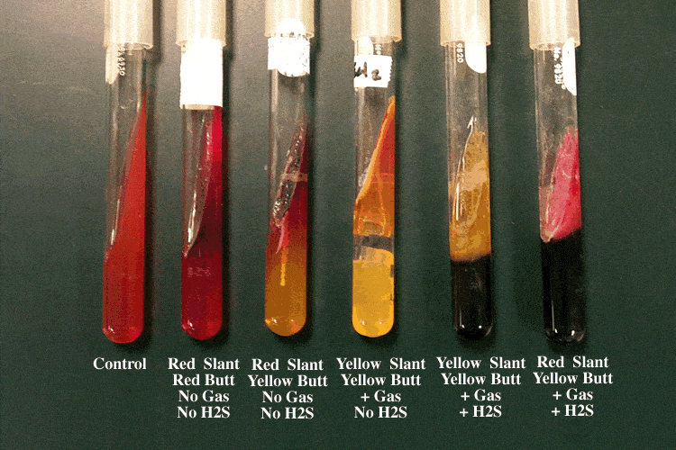

|  |  |  |
| --- | --- | --- |
| **Results (slant/butt)** | **Symbol** | **Interpretation** |
| Red/yellow | K/A | Glucose fermentation only; Peptone catabolized |
| Yellow/yellow | A/A | Glucose and lactose and/or sucrose fermentation |
| Red/red | K/K | No fermentation; Peptone catabolized |
| Red/no color change | K/NC | No fermentation; Peptone used aerobically |
| Yellow/yellow with bubbles | A/A,G | Glucose and lactose and/or sucrose fermentation; Gas produced |
| Red/yellow with bubbles | K/A,G | Glucose fermentation only; Gas produced |
| Red/yellow with bubbles and black precipitate | K/A,G, H2S | Glucose fermentation only; Gas produced; H2S produced |
| Red/yellow with black precipitate | K/A, H2S | Glucose fermentation only; H2S produced |
| Yellow/yellow with black precipitate | A/A, H2S | Glucose and lactose and/or sucrose fermentation; H2S produced |
| No change/no change | NC/NC | No fermentation |
| A=acid production; K=alkaline reaction; G=gas production; H2S=sulfur reduction | | |

|  |  |  |  |  |
| --- | --- | --- | --- | --- |
| **Name of the organism** | **Slant** | **Butt** | **Gas** | **H2S** |
| *Escherichia, Klebsiella, Enterobacter* | Acid (A) | Acid (A) | Pos (+) | Neg (-) |
| *Shigella, Serratia* | Alkaline (K) | Acid (A) | Neg (-) | Neg (-) |
| *Salmonella, Proteus* | Alkaline (K) | Acid (A) | Pos (+) | Pos (+) |
| *Pseudomonas* | Alkaline (K) | Alkaline (K) | Neg (-) | Neg (-) |

|  |  |
| --- | --- |
| **Organisms** | **Growth** |
| *Salmonella enterica* | Growth; red slant, yellow butt, gas positive, black-butt (H2S produced) |
| *Escherichia coli* | Growth; yellow slant, yellow butt, gas positive, no H2S produced |
| *Pseudomonas aeruginosa* | Growth; red slant, red butt, no gas, no H2S produced |
| *Shigella sonnei* | Growth; red slant, yellow butt, no gas, no H2S produced |
| *Citrobacter freundii* | Yellow slant, yellow butt, gas production; positive reaction for H2S Blackening of medium |
| *Enterobacter aerogenes* | Yellow slant, yellow butt, gas production; no H2S produced |
| *Klebsiella pneumoniae* | yellow slant, yellow butt, gas positive, no H2S produced |
| *Proteus vulgaris* | Red slant, yellow butt, no gas production; H2S produced |
| *Salmonella* Paratyphi A | Red slant, yellow butt, gas production; no H2S produced |
| *Salmonella* Typhi | Red slant, yellow butt, no gas production; H2S produced |
| *Salmonella* Typhimurium | Red slant, yellow butt, gas production; H2S produced |
| *Shigella flexneri* | Red slant, yellow butt, gas negative, H2S not produced |

**MR-VP Broth (Glucose Phosphate Broth)**

For performance of Methyl Red and Voges Proskauer tests in differentiation of coli-aerogenes group.

**Composition**

|  |  |
| --- | --- |
| **Ingredients** | **Gms / Litre** |
| Buffered peptone | 7.000 |
| Dextrose | 5.000 |
| Dipotassium phosphate | 5.000 |
| Final pH (at 25°C) | 6.9±0.2 |

|  |  |  |  |
| --- | --- | --- | --- |
| **Organism** | **Growth** | **VP test** | **MR test** |
| Escherichia coli ATCC 25922 | Luxuriant | Negative reaction, no colour change | Positive reaction, bright red colour |
| Enterobacter aerogenes ATCC 13048 | Luxuriant | Positive reaction, eosin pink/red colour | Negative reaction, yellow colour |
| Klebsiella pneumoniae ATCC 23357 | Luxuriant | Positive reaction, eosin pink/red colour | Negative reaction, yellow colour |

**Simmon citrate agar**

|  |  |
| --- | --- |
| **Ingredients** | **Grams per litre** |
| Sodium chloride | 5 |
| Sodium Citrate | 2 |
| [Ammonium dihydrogen  phosphate](https://en.wikipedia.org/wiki/Ammonium_dihydrogen_phosphate) | 1 |
| [Dipotassium phosphate](https://en.wikipedia.org/wiki/Dipotassium_phosphate) | 1 |
| Magnesium sulfate | 0.2 |
| [Bromothymol blue](https://en.wikipedia.org/wiki/Bromothymol_blue) | 0.08 |
| [Agar](https://en.wikipedia.org/wiki/Agar) | 15 |

<https://microbiologyinfo.com/simmons-citrate-agar-composition-principle-uses-preparation-and-result-interpretation/>

**LIM Medium (Lysine, Indole, Motility Medium)**

|  |  |
| --- | --- |
| **Ingredients** | **g/L** |
| Bacteriological agar | 2.7 |
| Bromocresol purple | 0.02 |
| Dextrose | 1 |
| L-Lysine | 10 |
| Peptone | 12.8 |
| Yeast extract | 3 |
| L-Tryptophan | 0.5 |

|  |  |  |
| --- | --- | --- |
| **Microorganisms** | **Specification** | **Characteristic reaction** |
| Enterobacter cloacae ATCC 13047 | Good growth | Lysine (-), Indole (-), Motility (+) |
| Proteus mirabilis ATCC 25933 | Good growth | Lysine (-), Indole (-), Motility (+) |

**Urea Agar**

Composition

|  |  |
| --- | --- |
| **Ingredients** | **Amount** |
| Urea | 20.0g |
| Gelatin Peptone | 1.0 g |
| Sodium Chloride | 5.0g |
| Phenol Red | 12.0 mg |
| Monopotassium Phosphate | 2.0g |
| Agar | 15.0 g |
| Dextrose | 1.0g |
| Demineralized Water | 1000.0 ml |

|  |  |
| --- | --- |
| **Control** | **Results** |
| Cryptococcus neoformans ATCC 34877 | Positive |
| Proteus mirabilis ATCC 12453 | Positive |
| Escherichia coli ATCC 25922 | Negative |

**Kovacs Reagent**

|  |  |
| --- | --- |
| **Ingredients** | **Amount** |
| p-Dimethylaminobenzaldehyde | 5.0 g |
| Isoamyl Alcohol | 75.0 mL |
| Hydrochloric Acid | 25.0 mL |